THE HIGHLAND DANCE COMPANY OF NZ
“JOURNEY OF THE CELTS”
EXCITING PERFORMANCE OPPORTUNITY FOR AUCKLAND SHOWS
“Journey of the Celts” will be staged in Auckland by The Highland Dance Company of New Zealand. A full-scale spectacular production incorporating Highland dance, music and song telling the story of the Scots migration to Aotearoa.
The Company invite Highland dancers to apply to join the cast of “Journey of the Celts”. Dancers are required in the following categories:
JUNIOR GROUP A
Dancers Under 8 years old , must be proficient at Highland Fling and Irish Jig. Kilts required.
JUNIOR GROUP B
Dancers 8 – 10 years old, must be proficient at Highland Fling, Irish Jig, Sword Dance and Sailors Hornpipe. Kilts required.
INTERMEDIATE GROUP
Dancers 10 - 14 years old, proficient in all dances named above plus Highland Reel and Seann Triubhas. Kilts required.
SENIOR GROUP
Dancers 14 years and over, proficient in all ten dances to senior level. Kilts required.
PERFORMANCE DATES
Three performances – first show Friday evening 10th April and 2 performances Saturday 11th April at Hawkins Theatre, Papakura, Auckland.
REHEARSAL COMMITMENTS
Venue – Auckland – to be confirmed once registrations received.
- Workshop Weekend
Saturday 21st February 4.30pm – 7.30pm Seniors only.
Sunday 22nd February 9.00am – 4.30pm – all dancers required. Venue and specific times will be emailed to successful applicants.

- Show Rehearsals
Wednesday 8th April – from 1pm onwards
Thursday 9th – Friday 10th April – all day. Specific times to be notified.

PRODUCTION FEE
There will be no charge to dancers for tuition and rehearsals associated with the show. There will, however, be a Production Fee payable to help offset costs of costuming, staging, venues etc.
Production Fees will be Juniors & Intermediates $15 , Seniors $25
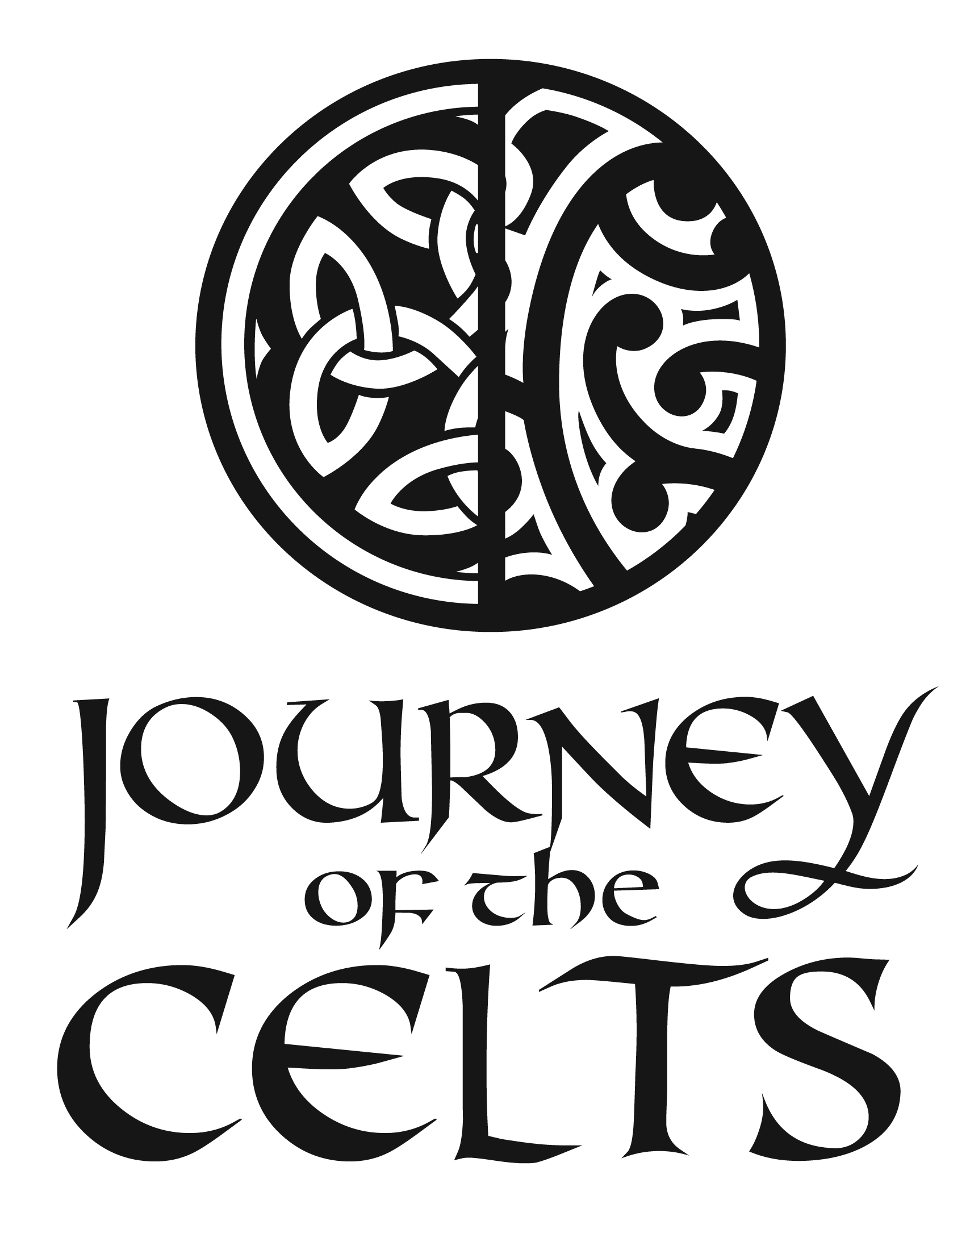

DANCERS APPLICATION FORM

NAME…………………………………………………………………………………………………………………………………
AGE………………………………………………..
PARENTS/GUARDIANS NAME…………………………………………………
POSTAL ADDRESS…………………………………………………………………………………………………………………
EMAIL ADDRESS……………………………………………………………
CONTACT PHONE NUMBERS………………………………………..
TEACHERS NAME………………………………………………………………….
TEACHERS EMAIL………………………………………………………………….
Please tick confirmation of following conditions
- I am available for all workshop and rehearsal times as notified Yes
- I agree to pay Production Fee as notified Yes
(to be paid once selection confirmed)
- I consent to publication for promotion purposes of any photos/images
taken during “Journey of the Celts” Yes
Please email application forms to the following address :
Mrs Julie Hawke julie_hawke@xtra.co.nz

APPLICATIONS CLOSE SATURDAY 06 FEBRUARY, NO LATE APPLICATIONS WILL BE CONSIDERED.
Applicants will be notified by email of the selection outcome.
SIGNATURE…………………………………………………………………………(to be completed by parent/guardian if under 18 years)

